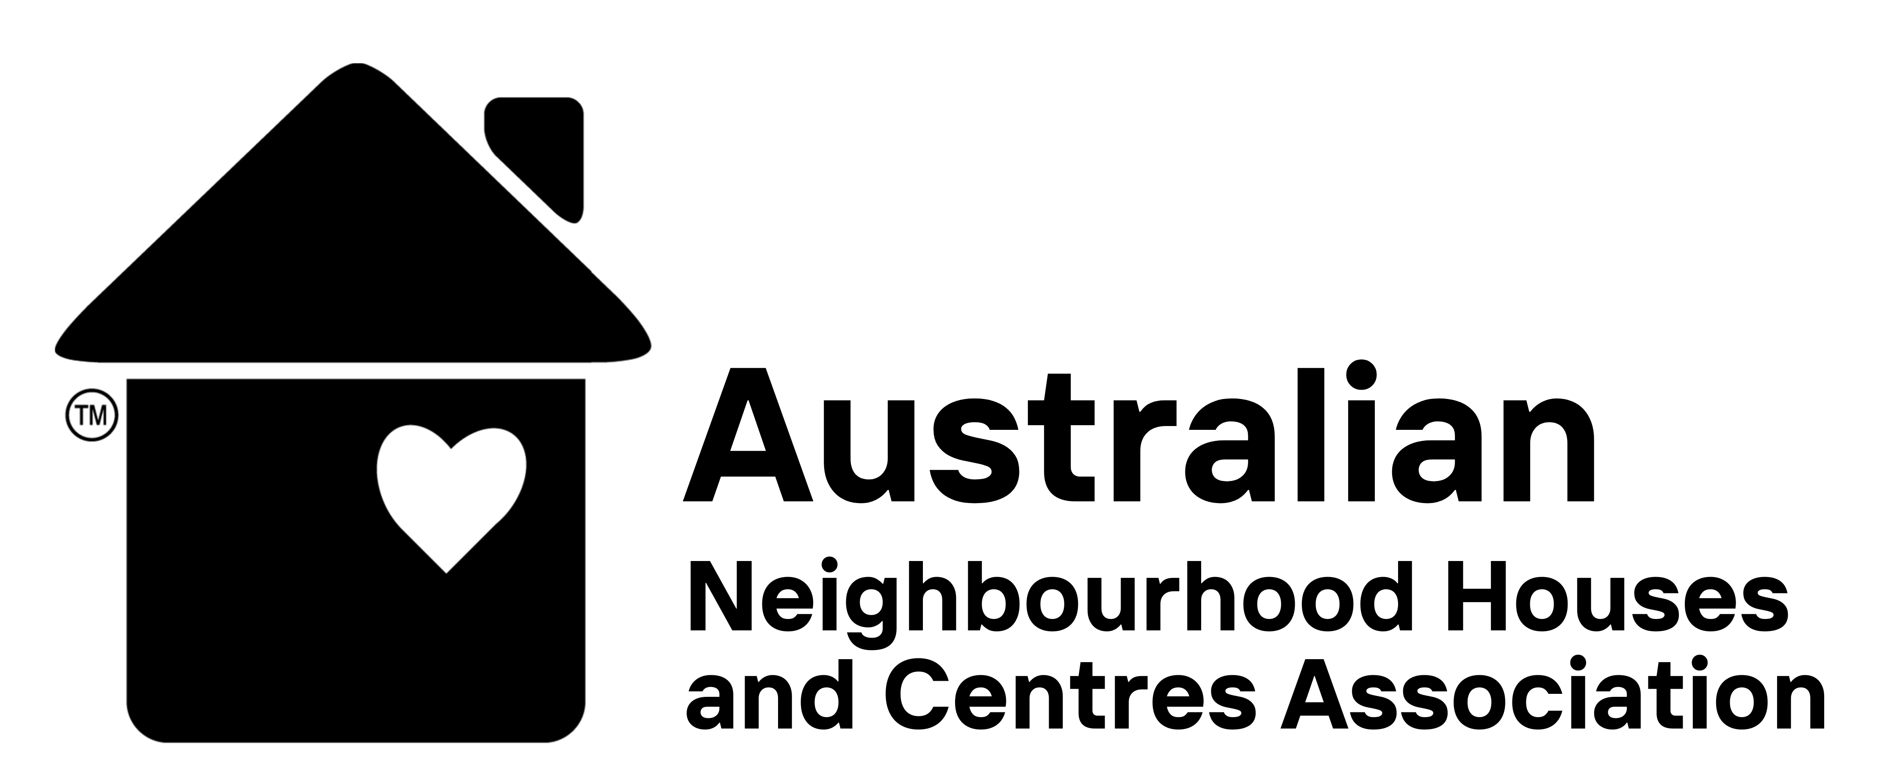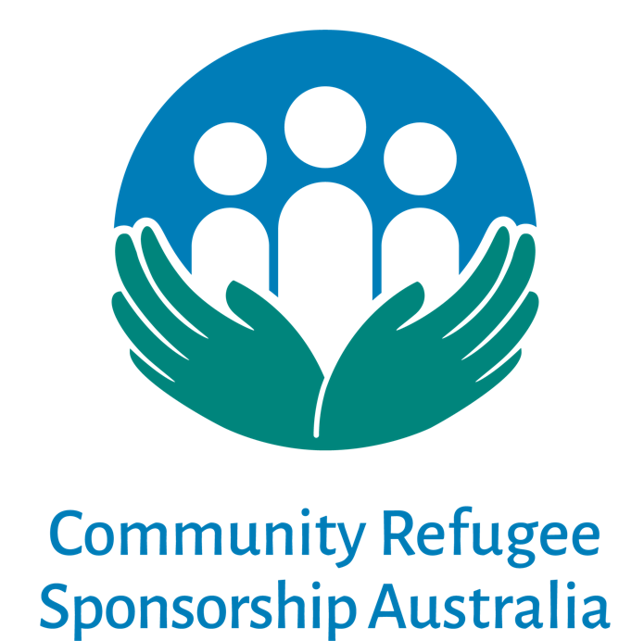

ANHCA Grants Policy

September 2022

Overview
This policy will guide the circumstances in which ANHCA makes grants of funds to community groups involved in one of Community Refugee Sponsorship Australia’s (CRSA) programs including:
- grants that draw on ANHCA’s general income or donations
- grants to groups who have fundraised in ANHCA’s name
The general objective is to ensure that when ANHCA makes a grant to any group or organisation, we have reasonable assurances that the grant will be used in a manner consistent with ANHCA’s purpose.

Documentation
Grants shall only be made subject to the terms and conditions set out below and upon a grant being made, the grantee shall be notified of the need to provide:
- a table summarising by category of expense how the funds have been applied within one month of the relevant period of the grant (typically a 12-month period)
- a statement, signed by two members of the group, that the funds have been used to support the settlement of a refugee individual or family in Australia through one of CRSA’s programs.
ANHCA shall also reserve the right to ask groups for documentary evidence of how funds were applied in the event that it wishes to do so.

See ANHCA’s Fundraising Guidelines for ANHCA Grant Terms and Conditions

