Fundraising Guidelines

Using the ‘Shout for Good’ platform to fundraise for your Community Supporter Group

September 2022

- Introduction
Using the ‘Shout for Good’ platform to raise funds for your Community Supporter Group (CSG) to participate in a Community Refugee Sponsorship Australia (CRSA) program is a convenient way to collect your group’s donations in one place and enables your Australian-based donors to make donations that are tax-deductible even if your group is not an incorporated entity or a registered charity. People who donate through this platform will be instantly issued with a tax-deductible receipt for donations of more than $2.
To use the platform for this purpose, CSGs can set up a fundraising page as a ‘Donor’ via Shout for Good and select Australian Neighbourhood Houses and Centres Association (ANHCA) as the charity the funds they raise will be donated to. CSGs participating in a CRSA program will be eligible to have any funds they have raised through this set up released as a grant to them by ANHCA. ANHCA will consult with CRSA to confirm a CSG’s participation in a CRSA program prior to funds being released and CSG’s will also be required to comply with ANHCA’s Grant Terms & Conditions (Annexure A) when spending the granted funds.

- Important requirements and limitations
ANHCA is a charity registered with the Australian Charities and Not-for-profits Commission (ACNC). As such ANHCA must ensure that funds raised in our name are only used for certain charitable purposes. By fundraising in ANHCA’s name via Shout for Good, you will need to understand these requirements and limitations and be willing to report back to ANHCA about how funds are spent by your group. Any unspent funds or funds spent inappropriately will need to be repaid to ANHCA or as directed by ANHCA.ANHCA is supporting the use of the Shout for Good platform to enable groups to fundraise the funds they anticipate requiring when welcoming and supporting a refugee household under one of CRSA’s programs. Groups should do this in a way that respects the privacy, autonomy, and dignity of the family that they are supporting.
To uphold this principle:
- Funds raised in ANHCA’s name cannot be spent outside Australia or for purposes not aligning with ANHCA’s purpose as outlined in ANHCA’s Grant Terms and Conditions.
- All funds raised on behalf of ANHCA via the Shout for Good platform must be paid out to your CSG within 3 months of the group commencing its support of the refugee household (i.e., within 3 months of the refugee household’s arrival date). Please note this does not mean that funds need to be spent within the first three months, just that fundraising activities via Shout for Good need to be wrapped up within this timeframe.
- Groups should not use the Shout for Good platform to run public appeals for specific items or needs of a household or individual member. For example, we would be alarmed to see fundraising appeals with specifics such as ‘Please help us raise $3,000 to pay for Zara to have her wisdom teeth removed.’

ANHCA reserves the right to amend these guidelines and requirements at any time to ensure sound governance and oversight of funds raised through ANHCA.
- Background - tax deductible fundraising via ANHCA
ANHCA is Community Refugee Sponsorship Australia (CRSA)’s primary fundraising partner.
ANHCA is the national peak body of Neighbourhood and Community Houses and Centres in Australia. Representing over 1000 member houses and centres across the country, ANHCA is committed to the development of place-based solutions to meet the economic, social, and civic opportunities and challenges facing communities. ANHCA and our member houses and centres have unparalleled reach into local communities located in some of the most geographically isolated and disadvantaged communities in Australia strengthening the foundations of communities to enable people and their families to thrive.
This partnership between CRSA and ANHCA will enable ANHCA to connect CSGs and refugee households with community support in Neighbourhood and Community Houses and Centres (NCHCs) wherever they are located. As such, this partnership with CRSA and its programs aligns with ANHCA’s purpose of supporting the activity and work of our national sector which meets our charitable purpose. ANHCA has established itself as a charity on the ‘Shout for Good’ platform to facilitate this.
When CSGs raise funds in this way, ANHCA needs to ensure that when funds are later directed by ANHCA back to the CSG by way of a grant, the grant will be used in a manner consistent with ANHCA’s purpose. Further guidance on what sorts of expenses can be paid for through these grants, and what sorts of records need to be kept by groups, is available in ANHCA’s Grant Terms & Conditions (Annexure A).
We encourage you to get in touch with ANHCA if you are not sure whether a particular type of expense falls within our purpose by contacting jarrah@anhca.org

- Essential reading before you proceed
It is essential that you read these guidelines and the following documents before you decide to proceed in setting up a fundraising page on the Shout for Good platform for ANHCA:
- ANHCA’s Fundraising Guidelines - Using the ‘Shout for Good’ platform to fundraise for your Community Supporter Group (this document)
- ANHCA’s Grant Terms and Conditions (Annexure A)
- ‘Shout for Good’ Setup Instructions (Annexure B). These instructions include important terms and conditions about the use of donated funds that you must include on your group’s fundraising page when you set up an account with Shout for Good.

- Setting your group’s fundraising page target
When CSGs raise money on behalf of ANHCA via the ‘Shout for Good’ fundraising platform, they are required to set a minimum target of $1,000 to be met per each fundraising page for the funds to be granted back to the group. There is also a ceiling amount of $25,000 per fundraising page.
Additionally, depending on the amount of funds raised and the other circumstances of your fundraising appeal, you may be subject to specific fundraising requirements depending on the states and/or territories in which you intend to fundraise. Complying with any local fundraising laws and regulations is your group’s responsibility.
As an example, in Victoria, any person/entity who seeks to fundraise must register as a fundraiser with Consumer Affairs Victoria unless you:
- raise a total of less than $20,000 for all fundraising appeals in any financial year;
- are not paid to conduct the appeals; and
- only use unpaid volunteers to run your fundraising appeals.
Prior to conducting your fundraising appeal, we recommend consulting with the relevant state / territory regulator (or seek independent legal advice) to ensure you are aware of and are complying with the relevant requirements that may apply to you and your fundraising appeal. Refer to ‘Annexure C: Fundraising regulation by State/ Territory’ in this document for more information.

- Setting your group’s fundraising page start and end dates
ANHCA recommends setting a fundraising page start and end date based on how long you think you will need to reach your target amount, and at what point you will need the funds in your group’s account if you do proceed with supporting a refugee household through a CRSA program.
To ensure funds raised by your group on ANHCA’s behalf via Shout for Good are only used to support the core responsibilities of CSGs involved in CRSA’s programs, the fundraising page must be wrapped up within 3 months of the household’s arrival.
Considering the resourcing and governance implications for ANHCA, when CSGs use the Shout for Good mechanism to fundraise, ANHCA will only release funds via a maximum of two payments per household that a CSG is matched with (provided the group qualifies to receive the grant under ANHCA’s Grants Terms & Conditions).
The first payment is generally requested by the group on the signing of the Settlement Deed with CRSA and prior to the arrival of the refugee household they will be supporting.
An invoice for the second payment must be received by ANHCA within 3 months of the household’s arrival. Your group’s Shout for Good fundraising page should also be closed within 3 months of the household’s arrival.
However:
- Groups can continue to raise funds after this at their discretion but not via the ANHCA Shout for Good mechanism.
- If a group wishes to support another refugee household, they can keep their Shout for Good fundraising page open and use any additional funds to support the next household they are matched with. Please notify ANHCA if this is your group’s intention.
- If a group has already closed its fundraising page prior to making the decision to support another household, they can reopen their fundraising page to fundraise for the next household they are matched with and set a new target. Please notify ANHCA if this is your group’s intention.

- Release of funds to groups
Scenario 1: CSG proceeds with supporting a refugee household through a CRSA program
ANHCA will require the group to sign and return a copy of ANHCA’s ‘Grant Terms and Conditions’ prior to funds being released. ANHCA will also consult with CRSA to confirm a CSG’s participation in a CRSA program prior to funds being released. CRSA will confirm a CSG’s participation in a CRSA program with ANHCA at the point a group’s Settlement Plan is approved by the CRSA program team and a Settlement Deed has been signed.
The funds raised via your group’s fundraising page can be paid out by ANHCA to your group as either a one-off lump sum OR via a maximum of two payments per household that the group is matched with (with a ceiling amount of $25,000 per refugee household that a group is planning to support).
To receive the funds they have raised, your group will need to issue ANHCA with an invoice for each payment. The invoice needs to include:
- your program group’s name
- the date the invoice was issued
- your program group’s bank account details
- your program group’s ABN (if they have one)
Groups will also be required to submit a ‘Statement regarding use of funds’ (template included in Annexure A: ANHCA’s Grant Terms and Conditions) within 30 days of the end of the formal program period (the program period ends 12 months after the date of arrival of the household your group is providing support to).
Scenario 2: CSG does not proceed to supporting a refugee household through a CRSA program
ANHCA will grant the funds to CRSA. CRSA will use any funds granted to them by ANHCA in accordance with CRSA’s charitable objects.
Scenario 3: Group does not raise the minimum required amount ($1000)
The funds from the group’s fundraising page for ANHCA will be granted to CRSA. CRSA will use any funds granted to them by ANHCA in accordance with CRSA’s charitable objects. Please keep in mind that you can always extend the end date of your fundraising page to give your group more time to raise enough funds to reach your minimum target.

- Group bank accounts
Funds granted to your group should be held in a bank account in the name of your Community Supporter Group. The banks listed below do allow unincorporated groups to open accounts:
- Beyond Bank allows unincorporated groups to open an account. Further information can be found on their website, or by contacting the bank.
- Bendigo Bank allows unincorporated groups to open an account. Groups need to open an enquiry first before they can start an application for a group account.
- Great Southern Bank allows unincorporated groups to open an account, provided each individual member opens/creates a membership with the bank first

- Record keeping requirements
To protect members of your group and ANHCA against any potential allegations of misuse of funds, it is important that you only spend the funds in accordance with ANHCA's grant terms and conditions and that you maintain records of how the funds were spent, including keeping receipts.

- Fundraising costs
CSGs can be reimbursed from the funds granted to them by ANHCA for reasonable out-of-pocket expenses incurred in running a fundraising appeal.
Examples of costs that are permitted to be reimbursed:
- Printing costs for fundraising event promotional materials
- Food and beverage costs associated with a fundraising event (e.g., cost of food and drinks for a sausage sizzle or fundraising dinner)
- Venue hire for a fundraising event
Examples of costs that are not permitted to be reimbursed:
- Volunteers’ time spent working on an appeal
- Any expense that is not directly related to the fundraising appeal e.g., incidental meals, parking and transport for volunteers while out fundraising
CSGs must account for all costs and expenses for which they seek to be reimbursed from the granted funds. Only costs and expense that have a “paper trail” (e.g., receipts) can be claimed. No more than 15% of total monies raised by a CSG via the Shout for Good platform and granted to the CSG by ANHCA can be claimed in fundraising costs or expenses.

- Transaction fees
Donations made via Shout for Good attract minimal transaction fees. There are no fees associated with setting up and using a donor page (such as what CSG’s will be using). Donations made via Visa and Mastercard carry no transaction fees on the platform. Transaction fees and taxes associated with American Express credit cards and PayPal transactions still apply (however donors can opt to cover these fees). Please note these fees are not subtracted from the ‘total funds raised’ displayed on your fundraising page so there can be some discrepancy between ‘amount raised’ and the amount ANHCA receives in its bank account.
Please email Jarrah at jarrah@anhca.org before issuing an invoice to confirm if any adjustments need to be made to reflect any transaction fees that have been deducted by AMEX or PayPal from the funds raised by your group via Shout for Good

- Administrative fees
ANHCA apply a 3% fee on the total funds raised by CSGs via Shout for Good to cover some of the administrative costs associated with offering this fundraising avenue to groups.
Please email Jarrah at jarrah@anhca.org before issuing your final invoice to confirm the adjusted amount.

- Other info about the Shout for Good platform
Donations made via Shout for Good will show up with the transaction name ‘Shout for Good’ in the donor’s bank statement. If you elect to use the Shout Ticketing product, please note that tickets are not tax deductible. Also note that funds raised via ticket sales will not be included in the Shout Fund product tally so be careful that you don’t go over $25k in funds raised. To view ticket details, you will need to request to be ANHCA’s Charity Partner on Shout for Good.
Please only use the Shout for Good Fund, QR or Ticketing product.
Annexure A:
ANHCA Grant Terms and Conditions
1. Grant Terms and Conditions
The following terms and conditions apply in addition to any specific terms and conditions stipulated in the Grant Application or ANCHA’s Fundraising Guidelines document.
- The Granted Funds must be used to support the successful settlement of a refugee individual or family in Australia under a CRSA program and in a manner consistent with ANHCA’s purpose and must not be sent by the group to any person or entity overseas without the express written permission of ANHCA.
- The group receiving the Grant Funds must:
  - Notify ANHCA promptly of any material change in the circumstances of the group or its members that may affect their ability to accept, use or administer the Granted Funds as is intended and required.
  - Maintain records of how the Granted Funds were used and provide such records to ANHCA at the end of the period during which the group supports a refugee household under the relevant CRSA program (in the form of the attached ‘Statement regarding use of funds,’ signed by two members of the group).
  - Maintain adequate records (including receipts) to enable the use of the Granted Funds to be identified, reported on, and checked readily and allow ANHCA or its auditor to inspect such records related to the funding on giving reasonable notice to the group.
- The group acknowledges that ANHCA is not responsible for any liabilities that may arise associated with the Granted Funds.
- ANHCA may set additional specific conditions or requirements on the granting or spending of Granted Funds if it is required to do so to comply with any contractual obligations, government requirements or to meet its obligations under the ANHCA Constitution or the Corporations Act.
- In the event that the group does not spend the entire amount of the Grant in line with these Terms and Conditions, any surplus funds must be returned to ANHCA or handled in accordance with ANHCA’s directions.

2. Acceptance of Grant Terms and Conditions
We agree to the above terms and conditions in connection with receipt of Granted Funds from ANHCA:
Name of Group Coordinator | Name of second group member  (deputy or other)
Signature | Signature
Date: | Date:

3. Statement regarding use of funds
On behalf of [name of your group], we confirm that:
- The funds were spent by our group to support the successful settlement of a refugee individual or family in Australia under a CRSA program.
- None of the funds were spent or transferred by our group outside of Australia.
- The table below provides an accurate summary of how the funds were used by our group; and
- To the extent that any funds granted to us by ANHCA were not used by our group in line with the CRSA program our group was engaged in, we have notified ANHCA of this and will return an equivalent amount to ANHCA or in a manner directed by ANHCA.
Note: To fall within ANHCA’s purpose of supporting the activity and work of our national sector which is committed to the development of place-based solutions to meet the economic, social, and civic opportunities and challenges facing communities, the Group has reasonable grounds for believing that expenditure will ​​promote and support the successful settlement, empowerment, self-reliance and capacity of refugees or their family members
Examples of expenditure that would fall outside of ANHCA’s purpose would include paying for:
  - daily living expenses beyond initial set up costs, where other sources of income are available
  - fines or late fees
  - holidays
  - luxury personal items

Category of Expense | Amount | Notes
Transit support to accompany refugee(s) to destination community
Transport for refugee(s)
Accommodation for refugee(s)
Temporary income support
Essential goods and other personal items for refugee(s) (on arrival) (e.g., food, clothes, smart phones)
Furniture and basic household goods (e.g., white goods, kitchenware, linen)
Other goods or services required by refugee(s) to support their settlement or integration (e.g., dental)
Education and employment set up costs (e.g., school uniform, textbooks, laptop)
Fundraising costs (e.g., venue hire, printing)
NB: No more than 15% of the grant can be used for fundraising costs or expenses.
Total spent

Amount of grant from CRSA

Surplus (amount of grant less amount spent)

Signed by:
Name of Community Supporter Group
Full name of person completing this statement on behalf of the Community Supporter Group (Group Coordinator)
Signature:
Email address:
Date:

Name of Community Supporter Group
Full name of person completing this application on behalf of the Community Supporter Group (Group Deputy)
Signature:
Email address:
Date:

Annexure B:
‘Shout for Good’ Setup Instructions
This document contains essential information including tailored terms and conditions about the use of donated funds that you must include when you set up your Shout for Good fundraising page CSGs should sign up for a donor account (not a charity account) and select Australian Neighbourhood Houses and Centres Association (ANHCA) as the charity the funds they raise will be donated to.
PART 1: Signing up for a ‘donor’ account with ‘Shout for Good’
Signing up for a ‘donor’ account on the ‘Shout for Good’ platform will allow your Community Supporter Group (CSG)to set up a fundraising page.
Step 1:
Go to https://shoutforgood.com/ and click on the ‘Sign Up’ button
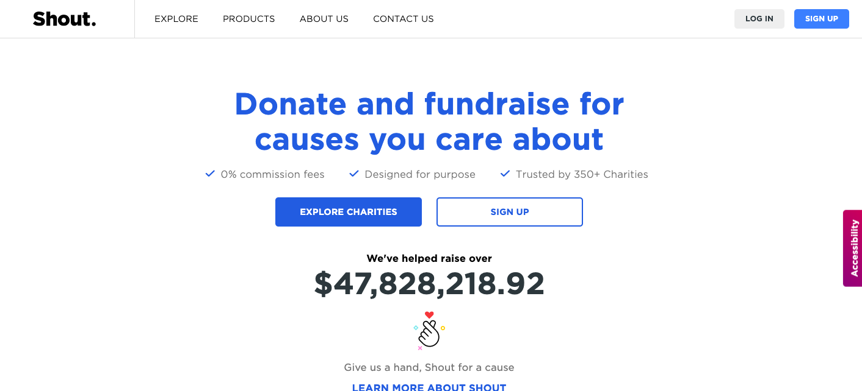
Step 2:
Enter your details to sign up as a ‘Donor.’ We recommend that the Group Coordinator uses their details to sign up. Everyone in the group will be able to share the fundraising page link with their networks.
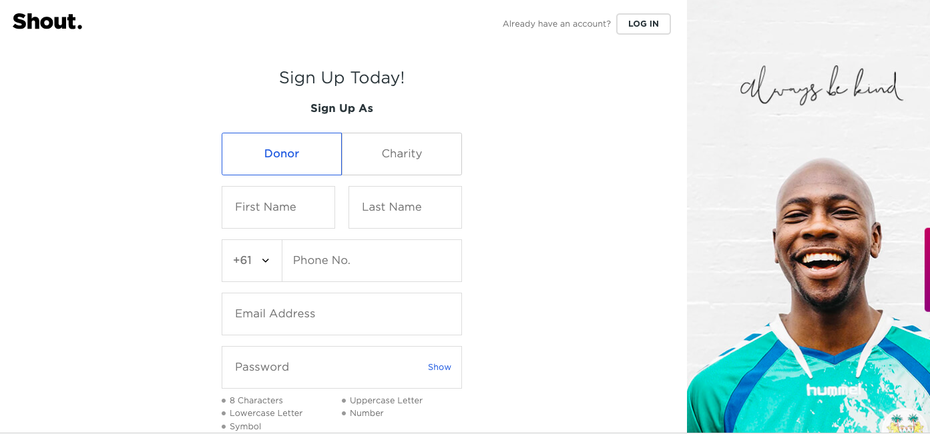

PART 2: Creating a fundraiser in your ‘Shout for Good’ account
Step 1:
Once you’ve logged in, click on the ‘Fundraisers’ tab on the left-hand side of your dashboard.
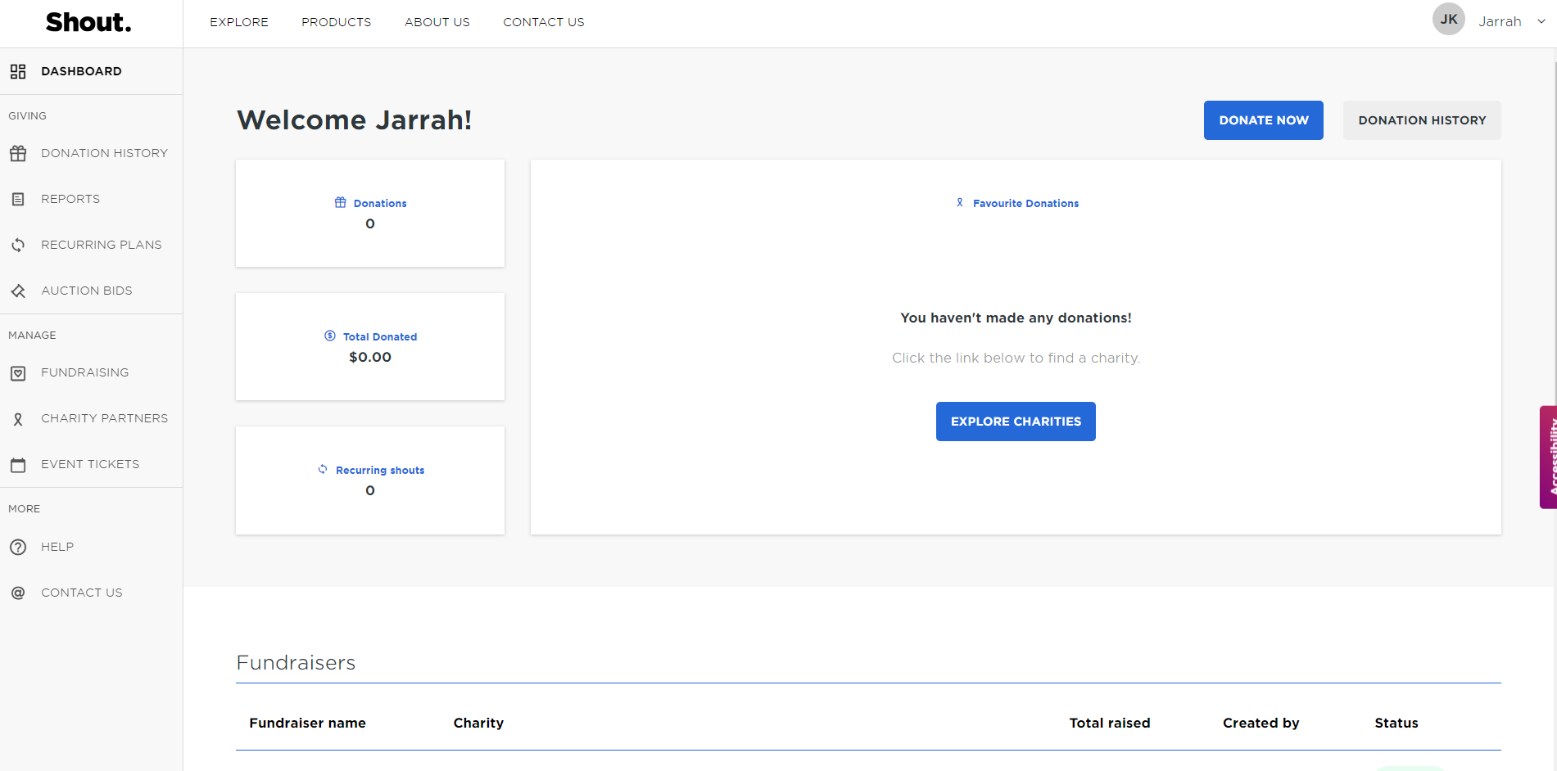
Step 2:
In the ‘Fundraisers’ tab click on the ‘Create a Fundraiser’ button
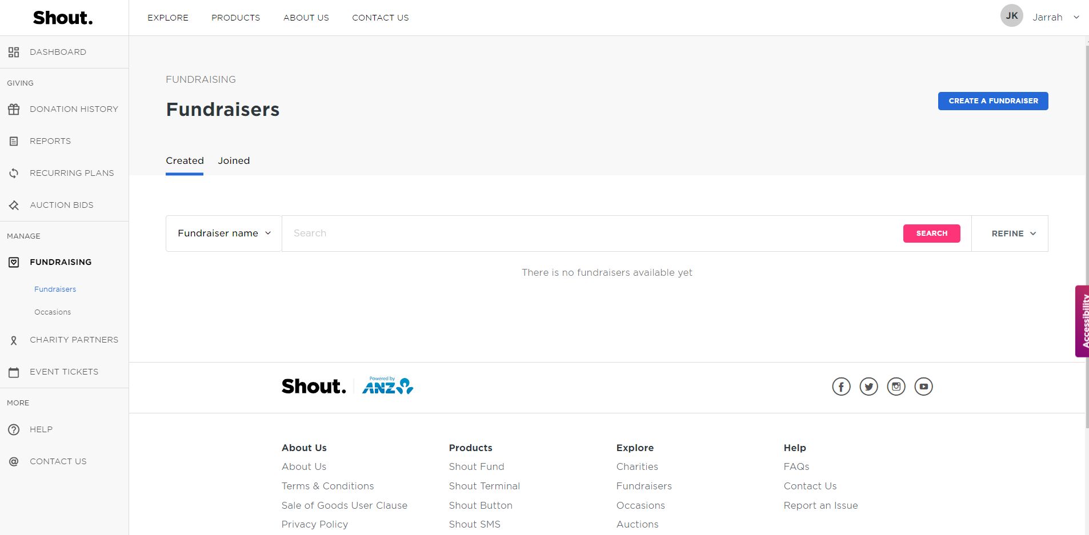
Step 3:
On page 1 of the ‘Create a Fundraiser’ form enter the relevant details outlined below:

- ‘Activate this fundraiser’ toggled to blue if you are ready for the fundraiser to be active.
- Enter a ‘Start date’ and an ‘End date’ for your group’s fundraiser.
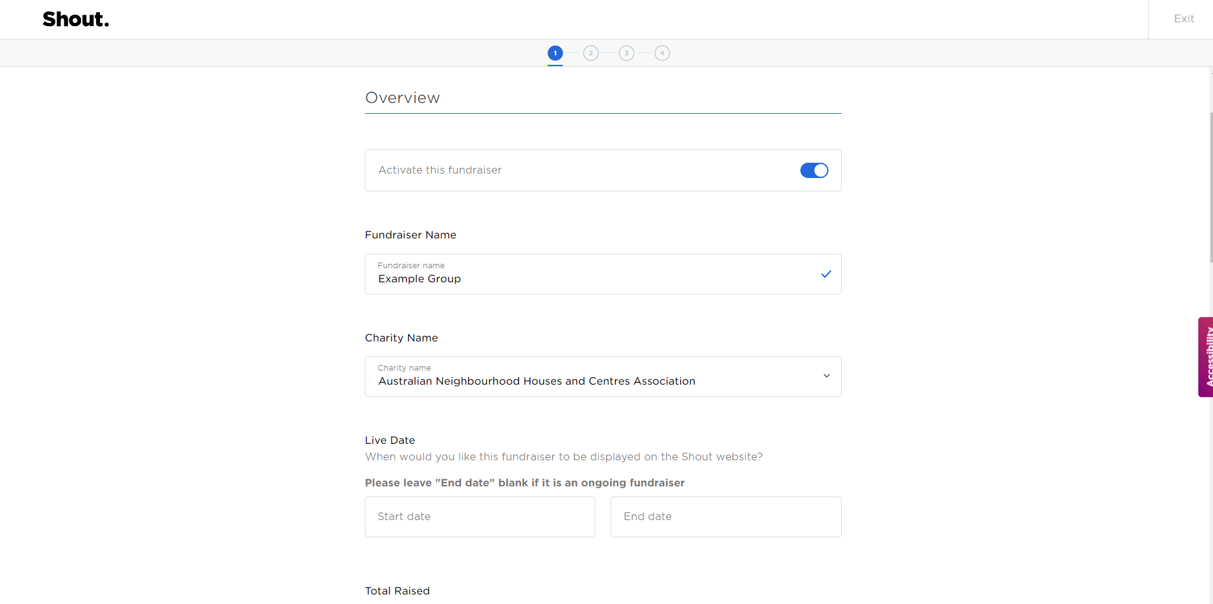
- For ‘Charity Name’ select Australian Neighbourhood Houses and Centres Association (ANHCA) from the dropdown menu.
- Enter your ‘Fundraiser name’. For clarity, we suggest using the name of your CSG.
- Under ‘Total raised’ toggle the button on (so it turns blue) if you would like the total raised to be visible on your fundraiser page
- Under ‘Fundraising goal’ toggle the button on (so it turns blue) if you would like your fundraising goal to be visible on your fundraising page.
- Please refer to Annexure C of this document for more information on the obligations you may have in relation to fundraising in various Australian States / Territories.
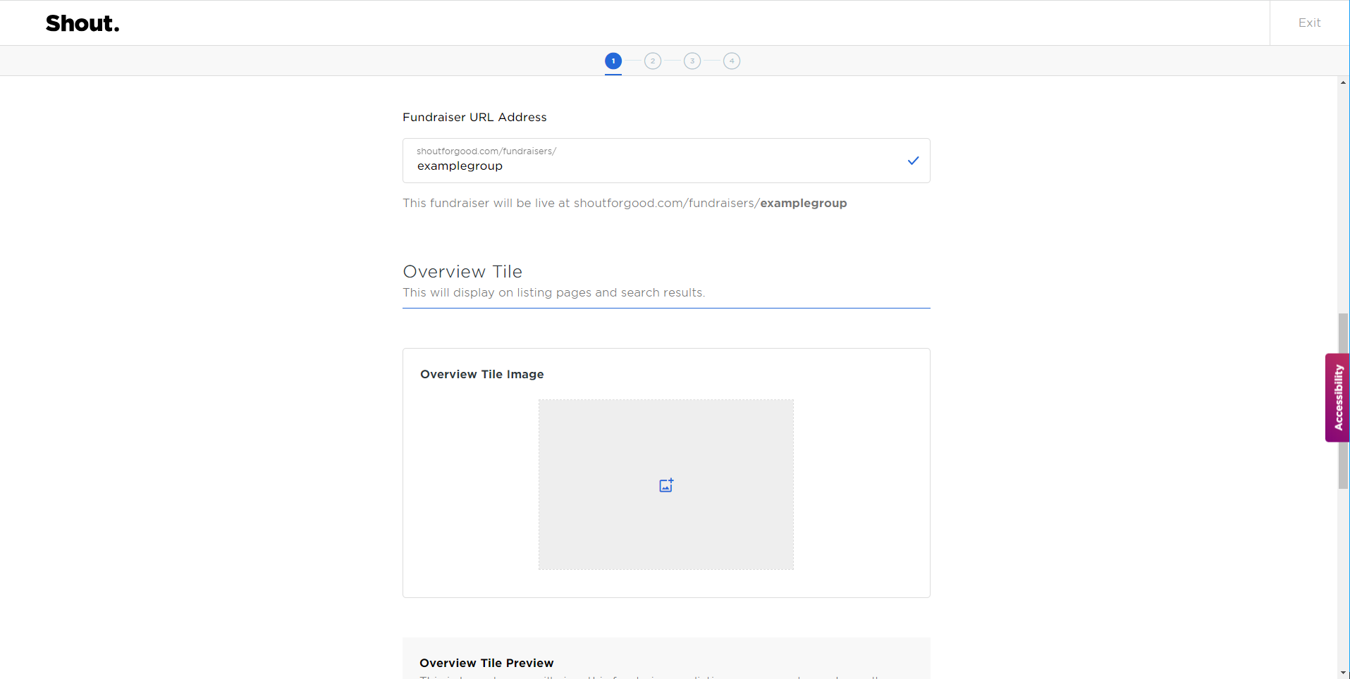

- Enter the ‘Fundraiser URL address’ using something that makes sense for your group e.g.shoutforgood.com/fundraisers/examplegroup
- Please leave the ‘Fundraiser date and location’ section blank. In the interests of simplicity ANHCA asks that your group doesn’t add a ‘Fundraiser date and location’ as the purpose of using Shout for Good is to enable fundraising through a fundraising page over several weeks or a few months.
- If you leave the ‘Fundraising logo’ blank ANHCA’s logo will automatically appear when the page is live. Alternatively, you can upload your group’s logo if you have one.
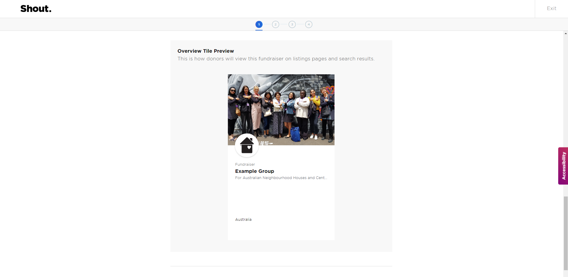
- In the ‘Overview tile image’ we recommend including a group photo. Remember to get permission to share this image online from all in the photo. To upload click on the blue ‘upload photo’ text. The recommended image size is 360px x 240px.
- When you have completed page one of the form click the blue ‘Continue’ button.

Step 4:
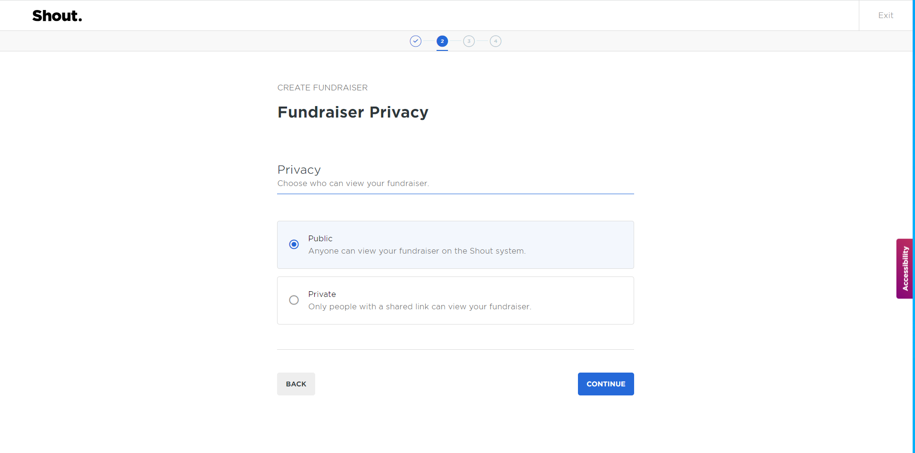
On page 2 of the ‘Create a Fundraiser’ form enter the details outlined below:
- Under ‘Privacy’ we recommend selecting the ‘Public’ option so that anyone can view your fundraiser on the Shout for Good website (including on Australian Neighbourhood Houses and Centres Association (ANHCA)’s Shout for Good charity profile page).
- Click the blue ‘Continue’ button.

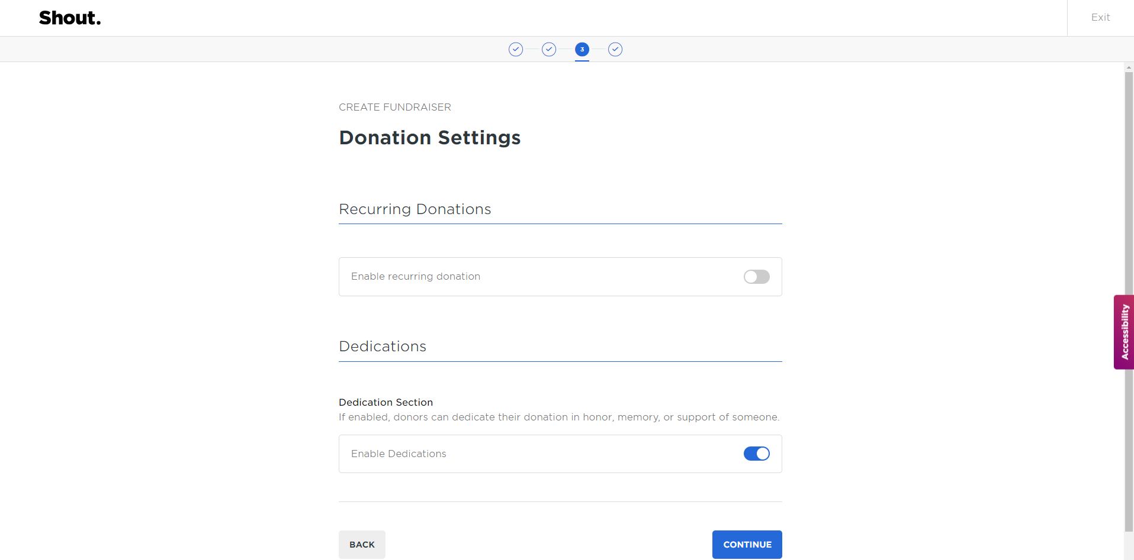
- Please leave the ‘Recurring donations’ option switched off (button will stay grey).
- Toggle the button under the ‘Dedication section’ on (button will turn blue) if your group would like to allow donors to dedicate their donation.
Step 5:
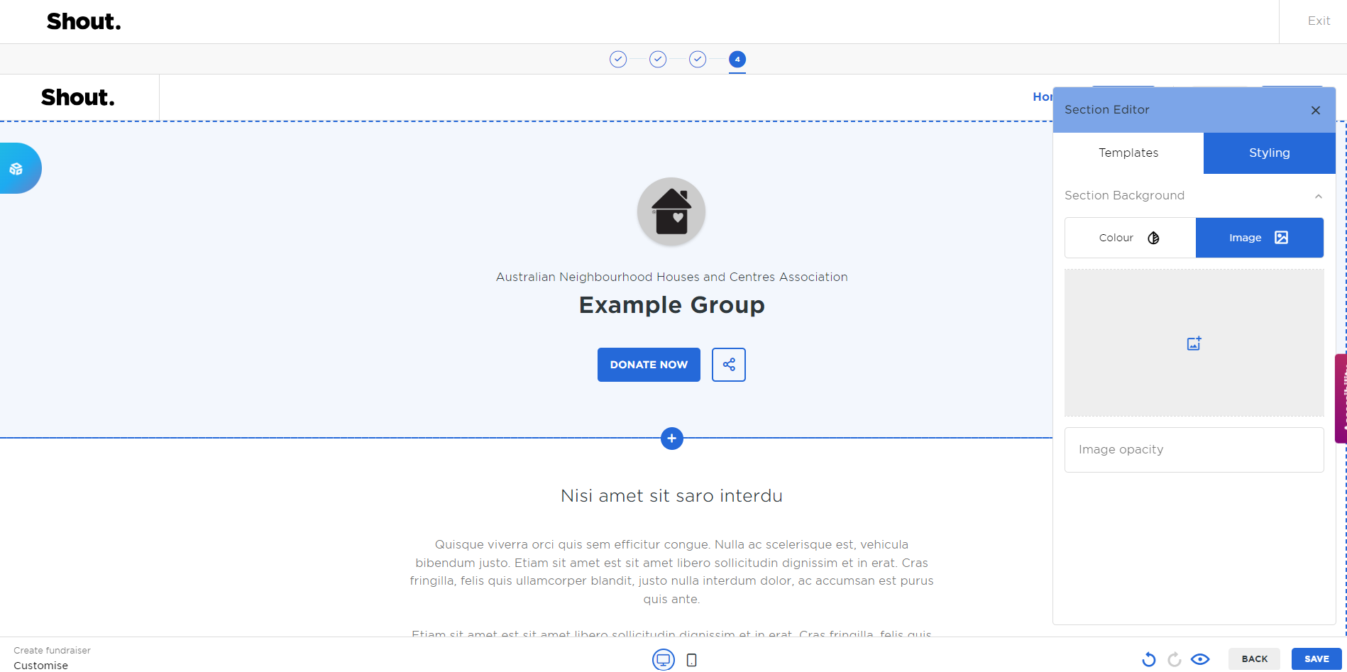
On page 4 of the ‘Create a Fundraiser’ form, you can now preview and customise your donation page including adding a banner and text.

- You can upload a ‘Hero Banner’ image by clicking on the pencil icon in the right head corner and selecting the ‘Styling’ tab and then ‘Image’. The recommended ‘Banner image’ size ratio is 16:9.
- You can add an introduction line and a description of your group by clicking on the text boxes. We recommend that you add a brief introduction line in the first text box and a small paragraph describing your group in the second.
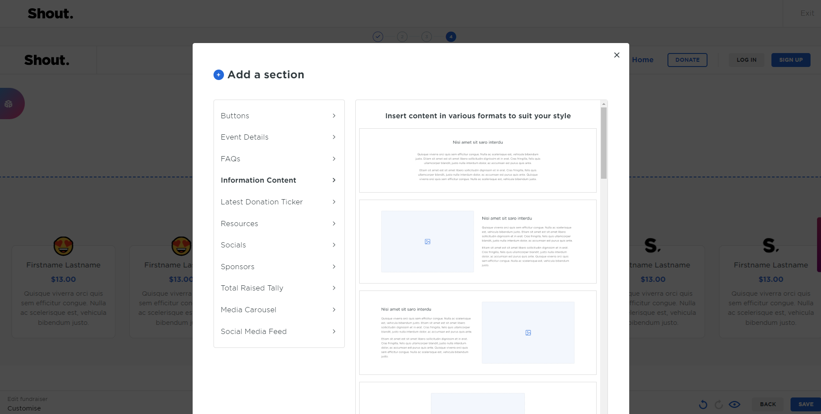

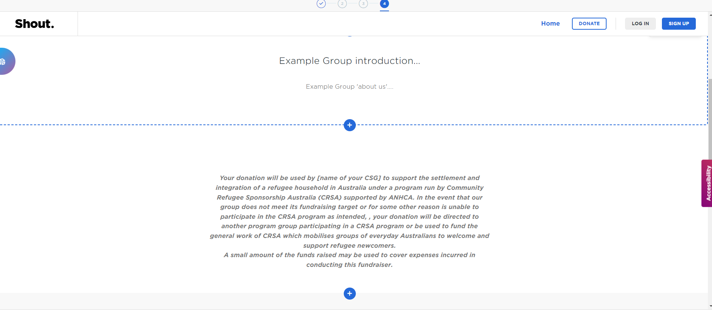
- You will need to add another section for the terms and conditions by clicking the ‘+’ button below your introduction. Select the ‘Information Content’ tab on the right and select the first format.

- You can delete the first line by clicking on the text box and selecting the trash icon. To add the terms & conditions, click on the second text box and copy and paste the following:
“Your donation will be received by ANHCA and earmarked to be granted to [name of your CSG] to support the settlement and integration of a refugee household in Australia under a program run by Community Refugee Sponsorship Australia (CRSA) in partnership with the Australian government. In the event that our group does not meet its fundraising target or for some other reason is unable to participate in the CRSA program as intended, your donation will be directed to another program group participating in a CRSA program or be used to fund the general work of CRSA which mobilises groups of everyday Australians to welcome and support refugee newcomers.
A small amount of the funds raised may be used to cover expenses incurred by ANCHA in conducting this fundraiser.”
- Press ‘Save’ in the bottom right-hand corner.
Congratulations! Your fundraiser is ready to go!

PART 3: Managing your fundraiser through the ‘Shout for Good’ portal
To manage your fundraiser page, click on the ‘Fundraisers’ tab on the left-hand side of your ‘Shout for good’ account dashboard.
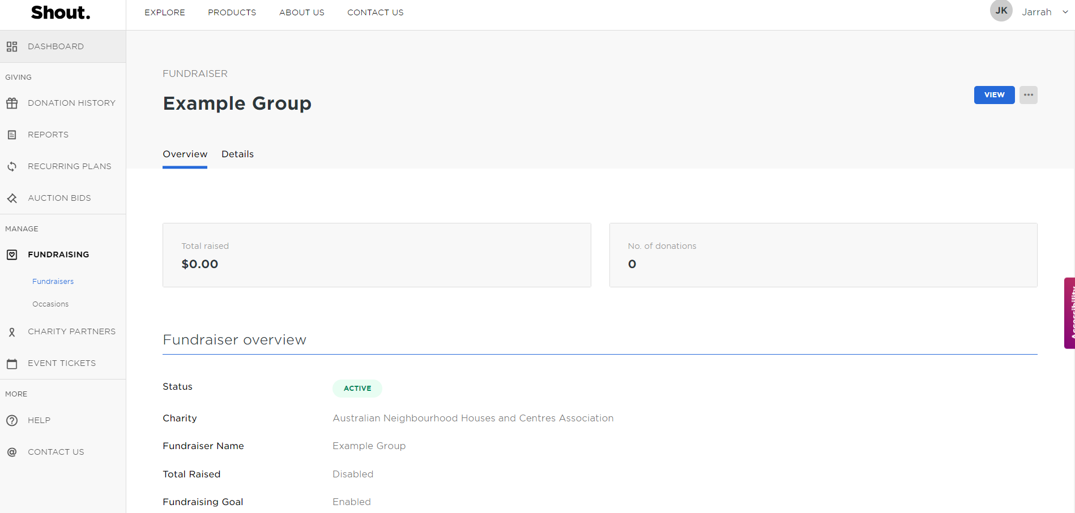
- Click on the ‘Overview’ tab in the menu to view the total amount your fundraiser has raised, how many donations have been made and any other activity on your fundraiser page.
- Click on the ‘Details’ tab in the menu to edit text or design elements on your fundraiser page.
PART 4: Troubleshooting and Support
If you have any questions about your fundraiser page on the ‘Shout for Good’ platform please:
- Check out their Frequently Asked Questions page at: https://shoutforgood.com/faqs or
- Contact them at: https://shoutforgood.com/contact
If you have any questions regarding the release of funds by ANHCA to groups raising money via the ‘Shout for Good’ platform, please:
- Refer to ‘ANHCA’s Fundraising Guidelines – Using the ‘Shout for Good’ platform to fundraise for your Community Supporter Group’
- If your questions are not addressed by the materials mentioned above, please contact ANHCA directly by emailing jarrah@anhca.org.
Annexure C:
Fundraising regulation by State/ Territory
For more information on fundraising obligations that may apply to you under various Australian State/Territory fundraising laws and regulations, please visit:
- Australian Capital Territory - Access Canberra – accesscanberra.act.gov.au
- New South Wales - NSW Fair Trading - fairtrading.nsw.gov.au/
- Northern Territory - Licensing NT - nt.gov.au/industry/licences/licensing-nt-online
- Queensland - QLD Office of Fair Trading - qld.gov.au/law/fair-trading
- South Australia - Consumer and Business Services - cbs.sa.gov.au/
- Tasmania - Office of Consumer Affairs and Fair Trading - cbos.tas.gov.au/home
- Victoria - Consumer Affairs Victoria - consumer.vic.gov.au/
- Western Australia - Department of Mines, Industry Regulation and Safety WA, Consumer Protection Division - commerce.wa.gov.au/consumer-protection

You can also find helpful information regarding the fundraising obligations that may apply to your organisation or group on Justice Connect’s Not-for-profit Law website at:
nfplaw.org.au/free-resources/fundraising-and-holding-events/fundraising

